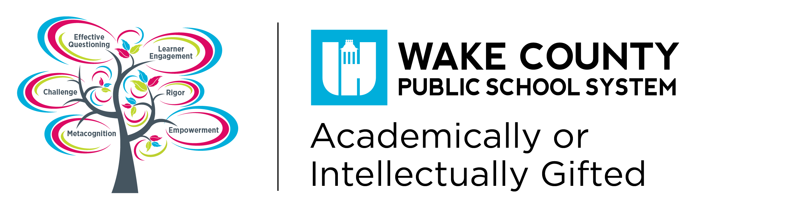

**Social and Emotional Needs of Gifted**

There are strong tendencies in the feelings and behaviors among gifted & talented students regarding their social and emotional development that can inform parents and teachers, helping them to understand the response they receive from their children and students. This presentation will address our best understanding of what giftedness is and how it affects individuals, not only in positive ways, but for some, in problematic ways. Information will also be shared about the emerging research on “Mindset” and why it is not helpful to refer to a child being “smart,” and the advantages inherent in focusing on effort and perseverance in the child’s performance and behaviors.

Crossroads II, 1400

February 25, 2016

6:30-7:30pm

110 Corning Drive

Cary, North Carolina 27518

**Richard Dennis Courtright,** **PhD**

**Gifted Education Specialist**

**Richard Dennis Courtright, PhD**, gifted education specialist for Duke TIP, is a lifelong educator with more than 40 years of experience. Dr. Courtright was an elementary and middle school classroom teacher, and a gifted education program administrator. He holds a BA, MA, and PhD in education from the University of North Carolina at Chapel Hill, with an emphasis on gifted and talented education. Dr. Courtright’s professional interests include consultation on curriculum and program development, program evaluation, and teacher training in gifted and talented education. He has co-written and co-edited several works, taught a variety of courses and workshops in general, gifted, and special education, and presented at state, regional, and national conferences.

*. * No Childcare available.*